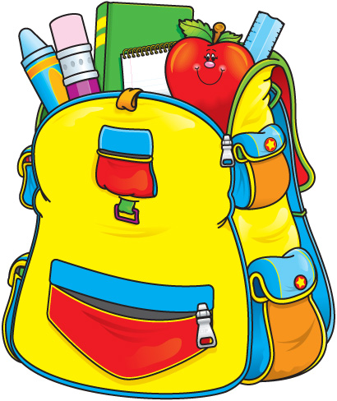 Kindergarten’s Supply List

Change of clothes (socks, underwear, shirt, and pants that are easy for your child to put on independently. PLEASE LABEL ALL OF YOUR CHILD’S CLOTHING.

- $20 in a sealed envelope with your Childs name for cooking and special projects
- 2 boxes of tissues
- 3 Packs of DRY ERASE markers
- 4 boxes of Ziploc storage bags (Gallon Size)
- 4 containers of Lysol Disinfecting Wipes/Clorox wipes (non-bleach)
- 2 liquid anti-bacterial hand soap with a pump
- 2 Purell hand sanitizer with a pump (12floz)
- 4 rolls of clear scotch tape
- 2 rolls of clear packing tape
- 3 pocket folders (plastic folders)
- 1 set of Crayola WASHABLE markers
- 1 set of Crayola crayons
- 1 set of Crayola Color Pencils
- 2 packs of white printing paper
- 1 pack of Laminating Sheets
- 1 box of clear sheet protectors
- 2 Primary Journal notebooks 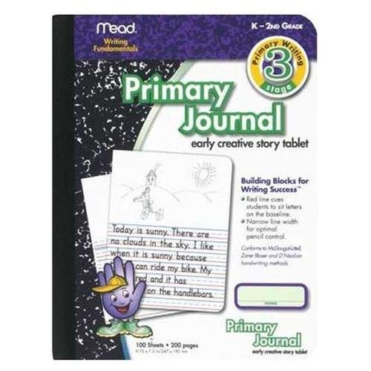(Sold at target, amazon, staples, office depot)
These notebooks have space for a picture on the top and lines for writing on the bottom

Thank you,
The Kindergarten Teachers

